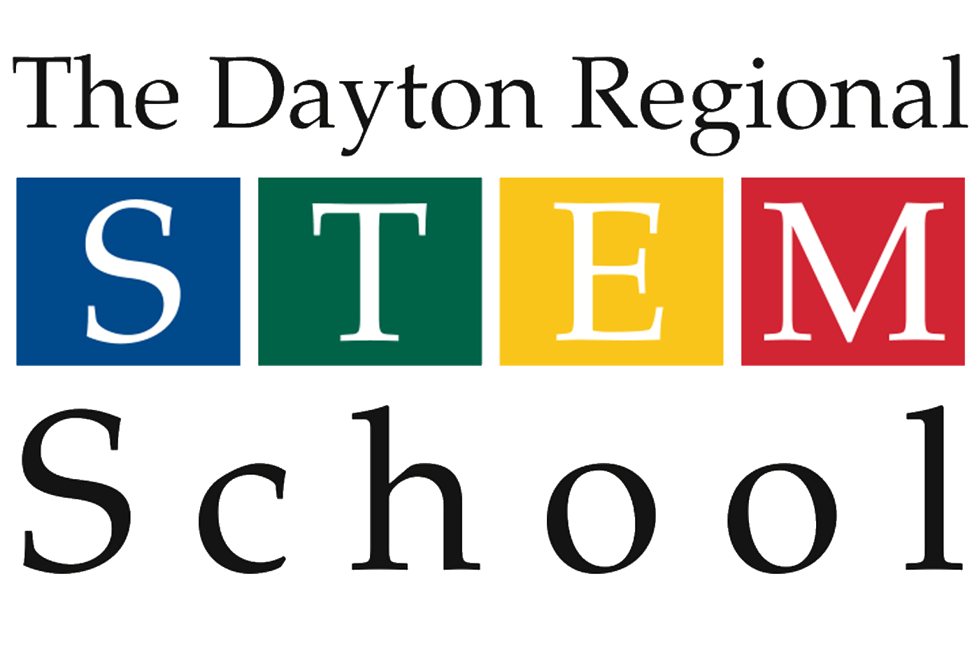

**SOCIAL MEDIA PLAN**

**Created by Sian Hernit and Emily Ritchie**

**Social Media Interns**

**July 2019**

**Summary**

The Dayton Regional STEM School’s Social Media Plan provides a framework for creating and posting content on the school’s official social media. This plan will help guide the school’s social media interns and administrative staff in creating better communication between the school and the community, and constructing a consistent, efficient, and functional brand.

**Users**

This plan should be used by all social media interns and administrative staff when creating and posting content, regarding those below.

**Target Audiences**

Regularly and strategically communicating school and student successes, engagement opportunities, important updates, and other news to our target audiences, The Dayton Regional STEM School bridges the gap between the school and the general public. This creates a strong community of individuals, families, and groups that are passionate about STEM education. Below is a list of segmented audiences that will be referenced in this plan:

* **Students** – The Dayton Regional STEM School serves 730 students in grades 6 through 12. The communication goal for this group is to keep them up-to-date on all aspects of the education process, both academic and social.
* **Parents** –Parents are encouraged to connect with the school via social media updates. Our goal is to create a sense of community among families that transcends the distance between them.
* **Prospective Families** – Families across the region with students currently in grades 5th-8th are considered part of this target market. This could also include current families with young siblings that do not yet attend the Dayton Regional STEM School. Students with a diverse range of backgrounds and ability levels make up this group. Our goal is to continue to encourage prospective students and families to apply by showing what our school has to offer.
* **Partners** – Industry partners and community leaders make up a vital stakeholder group for the Dayton Regional STEM School. Partners with a range of backgrounds, familiarity, engagement goals collaborate with students and staff in many unique ways. The goal for this target audience is to make partners aware of engagement opportunities, relevant updates, and school and student success.
* **Partner Educators** – The Dayton Regional STEM School takes pride in its culture of collaboration, openness, and transparency. We aim to share our best practices with other educators outside of the STEM walls for the benefit of children everywhere. Our goal for this audience is to keep them informed of all Training Center initiatives and build our brand as a leader in innovative education.
* **Leaders in Education and Government** – Advocacy is an important part of our strategic plan, therefore the goal is to connect with key members of the community to share successes, challenges, and opportunities for growth.

**Platforms**

Below is a detailing of each platform used at the school with corresponding usage information. It is important to note the target audience, frequency, and goal for each platform. The campaign suggestions are subject to change.

|  |  |
| --- | --- |
| **Platform** | **Facebook and Twitter** |
| **Target Audience** | Parents, Prospective Families, and Partners |
| **Frequency** | At least every other day |
| **Content** | Good school news |
| Community projects and events |
| Recruitment for partners and families |
| Call to action |
| Spotlights |
| Fundraising |
| **Notes** | Coordinate content across all platforms |

|  |  |
| --- | --- |
| **Platform** | **Instagram Posts** |
| **Target Audience** | Parents, Prospective Families, and Partners |
| **Frequency** | Monday, Wednesday, Friday (3 times a week) |
| **Content** | Events for that day |
| Projects going on |
| Recruitment for partners and families |
| Call to action |
| Spotlights |
| Why they came to stem |
| **Notes** | Coordinate content across all platforms |
| Use canva to format posts that don’t have a picture |

|  |  |
| --- | --- |
| **Platform** | **Instagram Stories** |
| **Target Audience** | Parents, Prospective Families, and Partners |
| **Frequency** | Six Times a week |
| **Content** | Mission Minded |
| Monthly updates ie. Chalk board, upcoming dates ect |
| Events |
| Clubs |
| Shout Outs |
| Fundraising (During a campaign |
| **Notes** | Coordinate content across all platforms |
| Use Canva to create content when there is no associated picture |

**Social Media Guidelines**

In order to create a consistent and professional social media brand, all users should adhere to the following guidelines:

* Don’t post without intention
* Use high quality photos or canva as an alternative content creator (no unoriginal work ie. Clip art, stock photos etc.)
* Use emoji’s sparingly
  + STEM color heart
  + Smiley faces
  + Other emoji’s relevant to post
* Information should be communicated in a positive tone
* Branding will be consistent across all social media platforms
* All content will be approved by Ms. Adams before posting
* Hashtag usage should be professional, mindful, and relevant to posts
  + #MissionMinded #STEMschool (good for any post)
  + #2020vision #ClassOf2020 (Senior Posts)
  + #BeyondSTEM #STEMinspires #RealWorldStartsHere (Outside events and partner events)
  + #PBL (Posts about projects)
  + #STEMschoolTalent (Spotlights)
  + #STEMmersion

**Branding Guide**

Follow these guidelines and logo specifications to ensure consistent image across all media applications. The official Dayton Regional STEM School Logo should be included on all Constant Contact emails. For official files or any questions regarding branding, contact Stephanie Adams, Community Outreach Director at stephanie.adams@wright.edu.

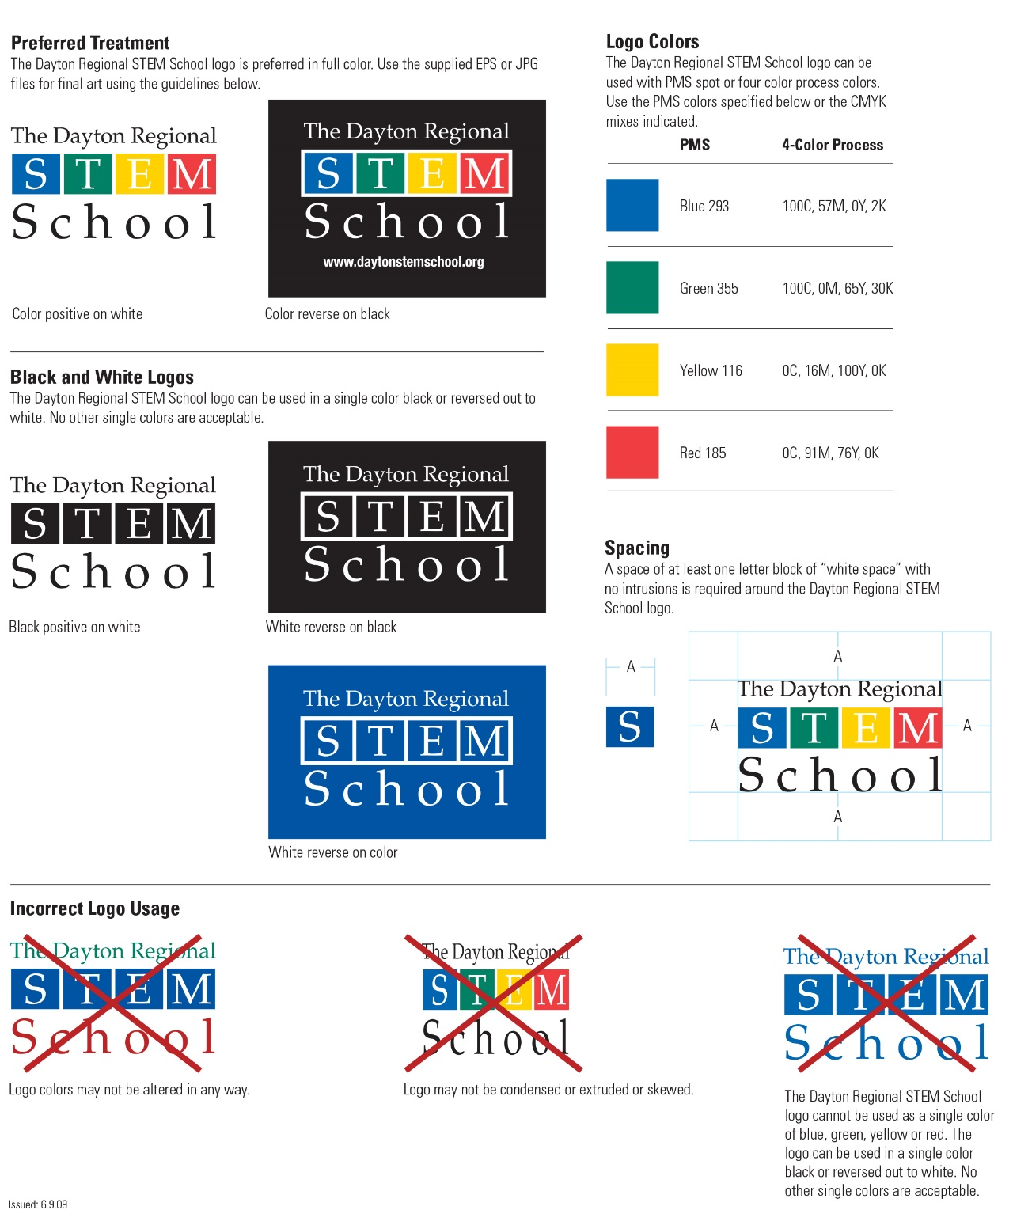

**Employee Social Media Policy**

This policy provides guidance for employee use of social media, which should be broadly understood for purposes of this policy to include blogs, wikis, microblogs, message boards, chat rooms, electronic newsletters, online forums, social networking sites, and other sites and services that permit users to share information with others in a contemporaneous manner.

The following principles apply to professional use of social media on behalf of The Dayton Regional STEM School (DRSS) as well as personal use of social media when referencing DRSS.

* Employees need to know and adhere to DRSS’s Employee Handbook, and other company policies when using social media in reference to DRSS.
* Employees should be aware of the effect their actions may have on their images, as well as DRSS image. The information that employees post or publish may be public information for a long time.
* Employees should be aware that DRSS may observe content and information made available by employees through social media. Employees should use their best judgment in posting material that is neither inappropriate nor harmful to DRSS, its employees, or customers.
* Although not an exclusive list, some specific examples of prohibited social media conduct include posting commentary, content, or images that are defamatory, pornographic, proprietary, harassing, libelous, or that can create a hostile work environment.
* Employees are not to publish, post or release any information that is considered confidential or not public, especially pertaining to students. If there are questions about what is considered confidential, employees should check with the supervisor.
* Social media networks, blogs and other types of online content sometimes generate press and media attention or legal questions. Employees should refer these inquiries to the Community Outreach Director, the designated DRSS spokesperson.
* If employees encounter a situation while using social media that threatens to become antagonistic, employees should disengage from the dialogue in a polite manner and seek the advice of a supervisor.
* Employees should get appropriate permission before you refer to or post images of current or former employees, students, families, or partners. A list of students who have not given social media permissions can be obtained from the Community Outreach Director.
* Social media use shouldn't interfere with employee’s responsibilities at DRSS. DRSS computer systems are to be used for business purposes only. When using the organization’s computer systems, use of social media for business purposes is allowed (ex: Facebook, Twitter, LinkedIn), but personal use of social media networks or personal blogging of online content is discouraged and could result in disciplinary action.
* Subject to applicable law, after‐hours online activity that violates DRSS Employee Handbook or any other company policy may subject an employee to disciplinary action or termination.
* If employees publish content after‐hours that involves work or subjects associated with DRSS, a disclaimer should be used, such as this: “The postings on this site are my own and may not represent DRSS positions, strategies or opinions.”